1. *LocusZoom: regional visualization of genome-wide association scan results.* Pruim 2010

Link: <https://academic.oup.com/bioinformatics/article/26/18/2336/208507>

**Summary**: Genome-wide association studies (GWAS) have identified hundreds of loci associated with complex human diseases and traits. This paper provides a graphical display of locus-specific association results and gives an overview of the extent of LD and the position relative to nearby genes and local recombination hotspots. An example visualization:

The authors built an web application for it. Source code is available in R

**Comment**: I need more background knowledge to understand this paper. But I think this looks like a direction to try…

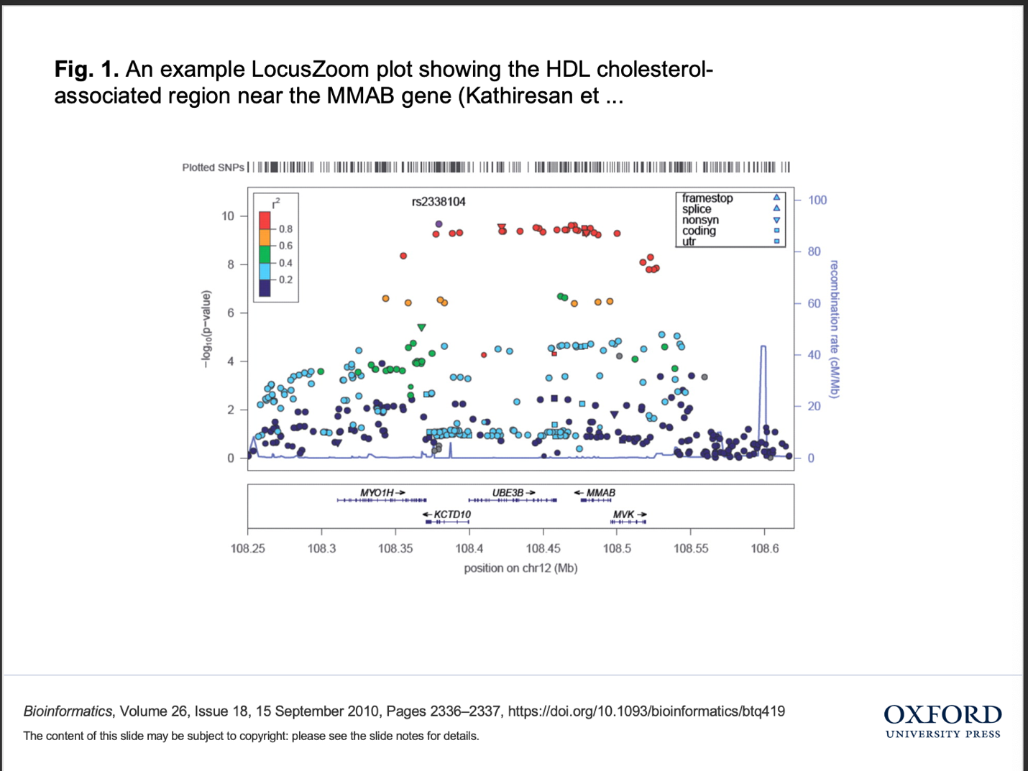

1. *Predictive Data Mining for Medical Diagnosis: An Overview of Heart Disease Prediction.* Soni,et al.,2011

**Summary**: The paper suggested that using Decision Tree and (sometimes) Bayesian classification will result in better results compared to other methods such as KNN, Neural Networks…

Association rules: to be used on the entire data set to extract rules…

**Comment**: This is a normal paper trying different algorithms.

1. *Genome-wide prioritization of disease genes and identification of disease-disease associations from an integrated human functional linkage network.* Linghu, 2009.

Link: <https://genomebiology.biomedcentral.com/articles/10.1186/gb-2009-10-9-r91>

**Summary**: In this paper the authors investigated into the genetic basis of diseases pairs having dissimilar phenotypes, for example, hypercholesterolemia and Alzheimer’s diseases.

**Method**: Network-based approaches. 1. Construct a gene-gene association network based on genomic/proteomic data. 2. Rank candidate genes based on network proximity to known disease associated genes. 3. Construct functional Linked Network in humans.

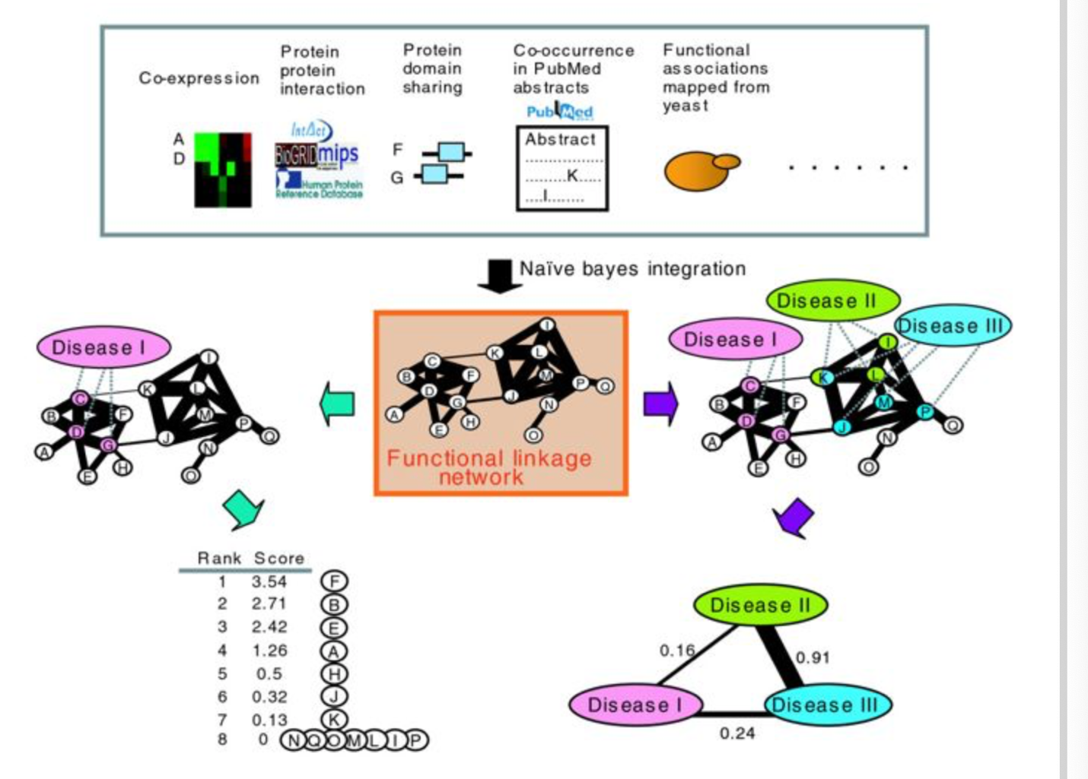

**Comments**: Patient Similarity, On the other hand, it is also disease similarity. We may go back to this paper if we want to also draw edges and nodes.

Drawbacks: This paper doesn’t provide interactive graph.